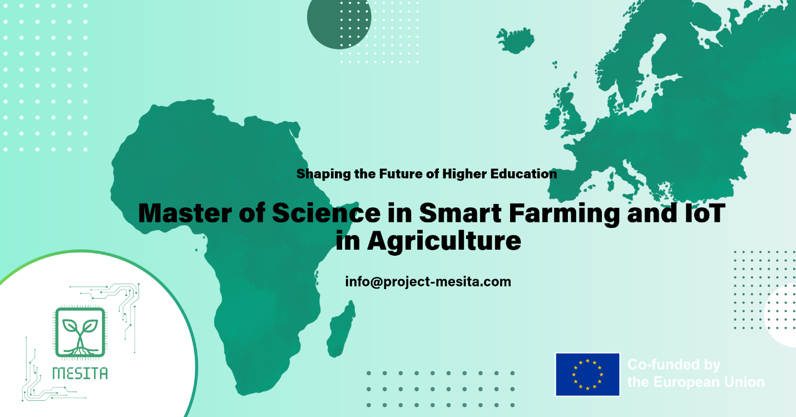

MESITA (Master of Science in Smart Farming and IoT in Agriculture) is a new Master’s programme established across four universities in Nigeria to modernise agriculture through smart farming, IoT, embedded systems, and AI-based applications. The programme is delivered by the Nigerian partner universities University of Port Harcourt, Obafemi Awolowo University, Michael Okpara University of Agriculture, Umudike, and Enugu State University of Science and Technology, in collaboration with EU partners University of Siegen, University of Food Technologies Plovdiv, and Wrocław University of Science and Technology, and with industry involvement from AlumUnite Limited.
The programme equips graduates with practical skills in precision agriculture, embedded systems, and AI-based farming applications, while promoting sustainable and climate-smart practices. The programme strengthens university–industry collaboration and supports entrepreneurship and employability in the smart agriculture sector. Through structured knowledge and technology transfer from the European Union to Nigeria, MESITA accelerates digital transformation in agriculture. Beyond technical skills, MESITA strongly emphasizes entrepreneurship and employability: students are trained to turn smart-agriculture ideas into deployable solutions and viable agri-tech ventures, supported through challenge-driven projects, industry-linked problem statements, and innovation-oriented learning pathways. Its expected impact includes higher productivity and efficiency, improved food security, new jobs, and stronger environmental sustainability—while also supporting gender inclusion in agribusiness and broader climate action.

